HCI Assignment 2

Group members

Arifullah Jan | HASSAN JAVED

BSCS 6A

[Year]

# Rice Cooker

<https://www.amazon.com/Aroma-Housewares-ARC-2000ASB-Professional-cooked/dp/B009XI4Z10>

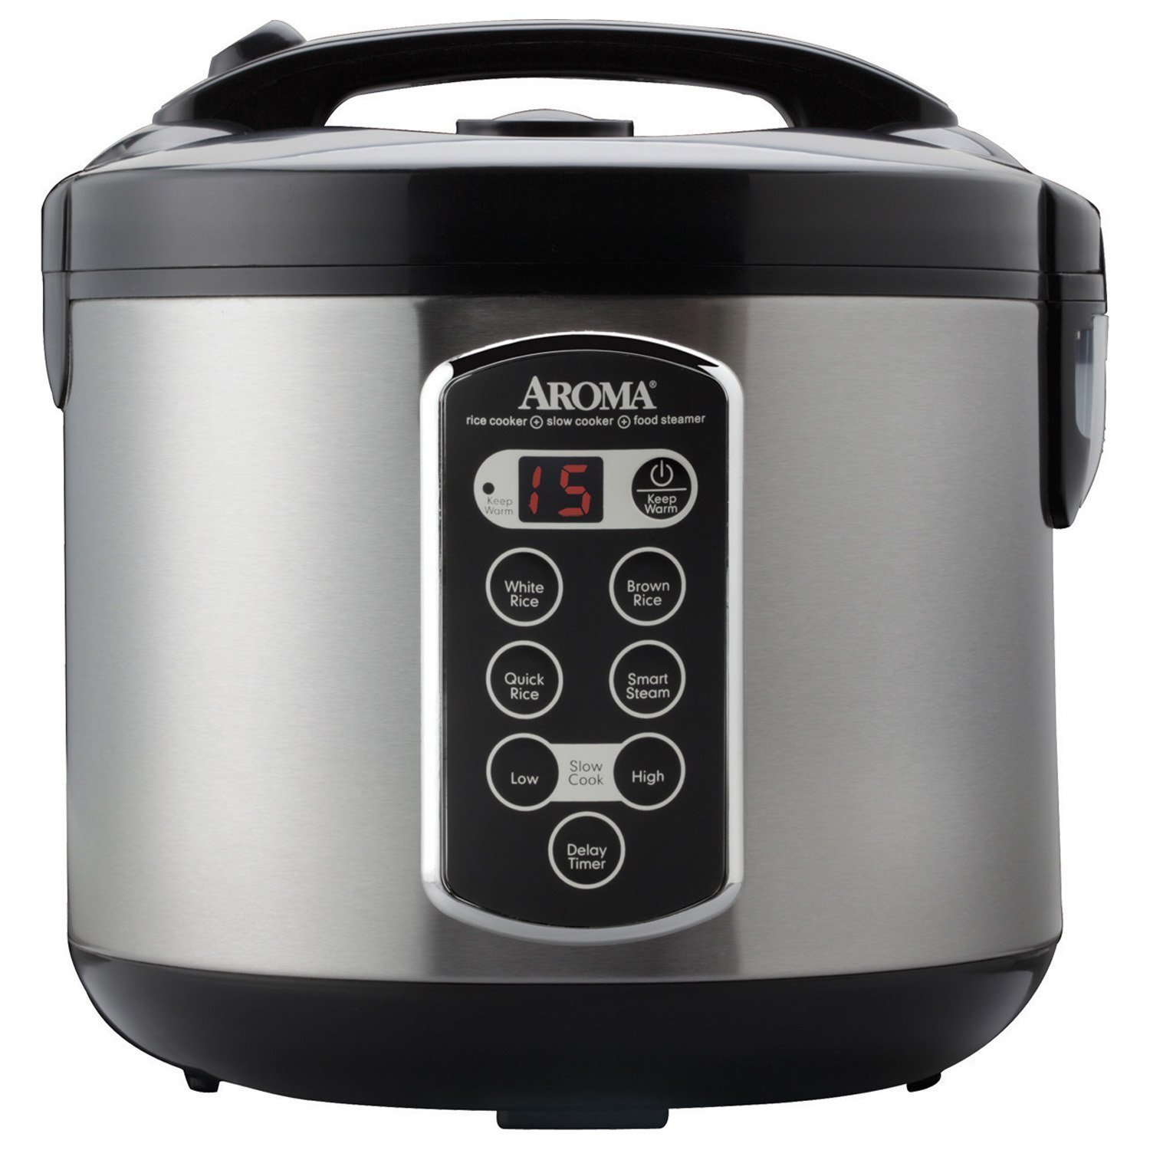

# Usability Goals

## Visibility

All the buttons are clearly visible

## Affordance

The user interface is simple and is quite straight forward. So, affordance is no issue. The buttons have clear names.

## Feedback

The timer display is giving the feedback. The buttons should give feedback too.

## Constraint

The constraint regarding user interface.

## Mapping

The mapping is correct.

# What features should be part of the interface.

* The timer should be visible from a wide angle. So, a control panel of lesser area won’t be good. The control panel should be fit in the cooker’s body without any bump.
* There should be some default settings in safe range so that the user could be able to start the cooking process with just one button.
* There should be very clear indicator that the cooking process in running.
* The buttons and controls should be physical and usable in kitchen conditions, No touch display etc.
* The buttons should be of radio type and the selected option’s button’s back lit should be on another color so that the user can get the feedback.
* A transparent lid will give an extra feedback.

# Wire Frame

15 min

Transparent

Step 1 radio buttons

start

Can start with default options too